

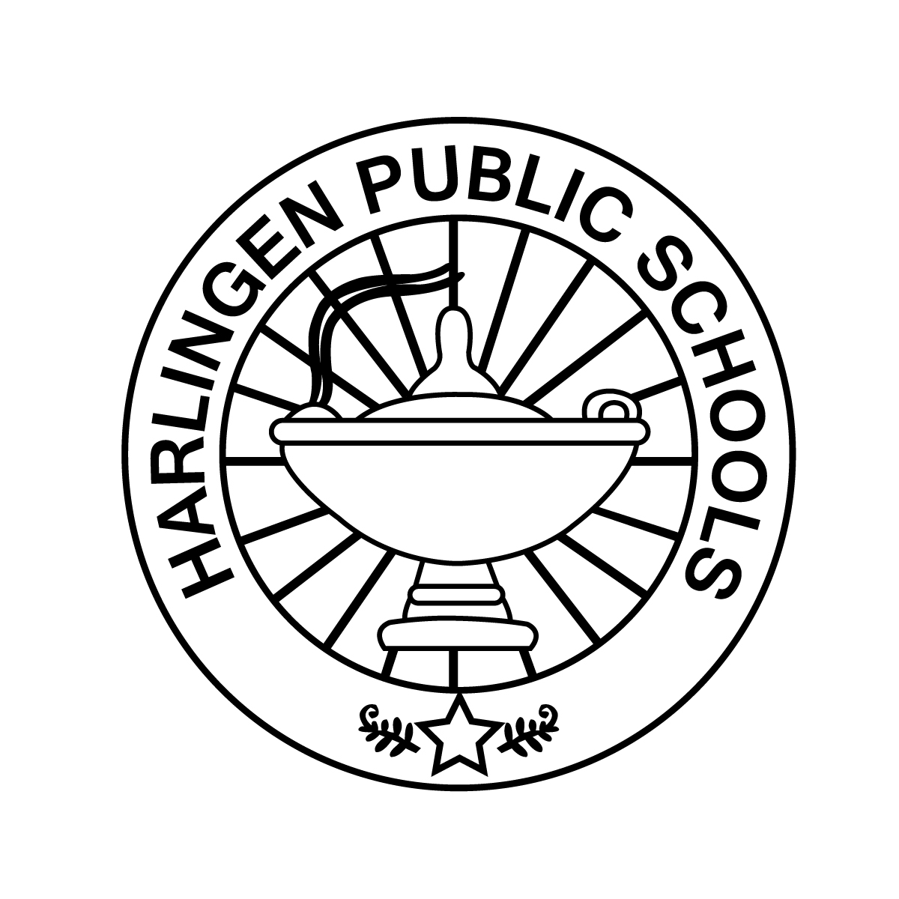

Information on the HCISD Pre-AP Summer Reading Program can be found at:

http://www.hcisd.org/Page/6174

Deadlines!

Summer Reading Project is due on September 5, 2014

Schawn Wreden, ELA Content Specialist

407 N. 77 Sunshine Strip

Harlingen, Texas 78550

schawn.wreden@hcisd.org

Summer Reading is Easy!

There are many options available for selecting a book for summer reading. The Harlingen Public Library has many of the titles available and your Middle School Campus English Department will also have books you can check out over the summer.

Of course, you can always purchase a copy of the novel and start your own library, or download the book to your electronic device. Be sure to check out **Overdrive** on the HCISD website to see if the novel you want to download is available there for free!



Harlingen CISD

Pre-AP

Summer Reading Information

7th Grade





PLACE PHOTO HERE, OTHERWISE DELETE BOX

***We encourage parents to review the book titles with their students to make the best choice for their reading and maturity level.***

Student Assignments

7th Grade students will need to complete two assignments on the novel they choose.

Assignment 1: Students will complete the Summer Reading Assignment Worksheet.

Assignment 2: Students will create a Page Turner Video on their novel following the instructions on the Guide Sheet.

All instructions for the Student Assignments can be found at:

http://www.hcisd.org/Page/6174



* List your services or products here.
* List your services or products here.
* List your services or products here.
* List your services or products here.
* List your services or products here.

*Why does Harlingen CISD have a Middle School summer reading program?*

Harlingen CISD requires middle school students who enroll in Pre-AP English to read over the summer for several reasons:

* Allows teachers to begin literary discussions right away
* Students maintain their English Language Arts skills over the summer when they read
* Encourages independent reading, analysis and life-long learners
* Exposes students to literature they might not choose on their own

**7th Grade Selection List**

***Please select ONE of the novels from this list:***

* Drums, Girls and Dangerous Pie by Jordan Sonnenblick
* Everlost by Neal Shusterman
* La Linea by Ann Jaramillo
* The Laura Line by Crystal Allen
* Day of Tears by Julius Lester
* Dairy Queen by Catherine Gilbert Murdoch
* Jeremy Fink and the Meaning of Life by Wendy Mass
* When You Reach Me by Rebecca Stead
* Bomb: The Race to Build – and Steal – the World’s Most Dangerous Weapon by Steve Sheinkin
* Toads and Diamonds

by Heather Tomlinson

* Alex Rider: Stormbreaker by Anthony Horowitz
* The Lost Hero by Rick Riordan
* The Red Pyramid by Rick Riordan
* White Fang by Jack London

